Spring

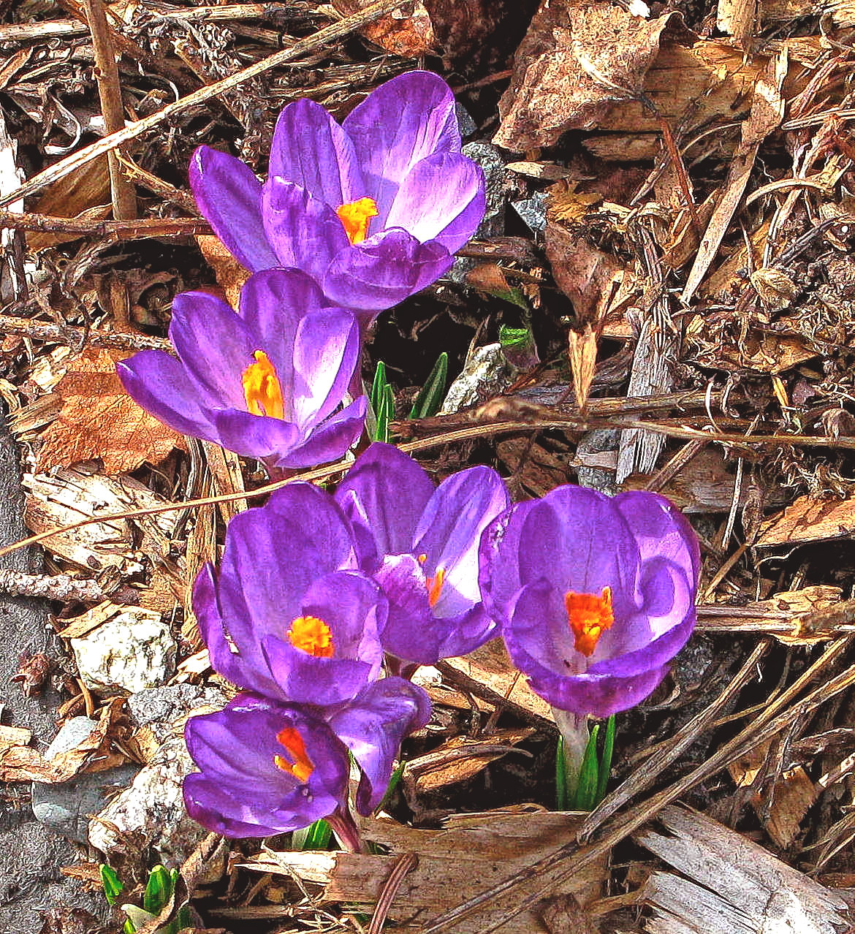
Steinbach United
April 8, 2018

“God wills our liberation, our exodus from Egypt. God wills our reconciliation, our return from exile. God wills our enlightenment, our seeing. God wills our forgiveness, our release from sin and guilt. God wills that we see ourselves as God’s beloved. God wills our resurrection, our passage from death to life. God wills for us food and drink that satisfy our hunger and thirst. God wills, comprehensively, our well-being—not just my well-being as an individual but the well-being of all of us and of the whole of creation. In short, God wills our salvation, our healing, here on earth. The Christian life is about participating in the salvation of God.”
― Marcus J. Borg, The God We Never Knew: Beyond Dogmatic Religion To A More Authenthic Contemporary Faith

Easter Morning Service April 1, 2018
Thank you’s to all Volunteers helping in today’s Worship service
Gay Boese & Jan van Aerselaer – Worship Service
Ushers – Andrea, Ally & Anya Klassen; Pianist – Lori Reimer

Easter Morning Service April 1, 2018
Sunday Morning Service April 8 , 2018

Thank you’s to all Volunteers helping in today’s Worship service
Guest Speaker –Bonnie Loewen - Prairie Wind House Church
Pianist – Alex Major; Ushers – Martha Werry, Bonnie Morrow

Welcome
Announcements and Sharing of Celebrations
Songs- “God of the Bible” MV 28
“The Spring Has Come” VU 187 Prayer- (by Gretta Vosper from her book “Holy Breath”)

Sharing & Learning

Song- “River Running in You and Me” MV 163
Scripture Reading – Isaiah 42:14-17 - Jan Van Aertaelaer

Reflection – “Spring Cleaning!”

Song - “Come Touch Our Hearts” MV 12
Minute for Mission - Organ Donation across “Enemy Lines”

Offering -
Offering Song - “What Can I Do?” MV 191

Prayers of the people
Lord’s prayer (spoken)

Song- “May the God of Hope Go with Us” VU 424

Blessing and Passing the Peace

“Peace Starts with a SMILE”

NEWS AND NOTES

Looking Ahead:
Tues. April 10th – 7:15PM Worship Team Meeting
Friday April 13th – Messy Church 5-7PM
Sunday, April 15th – Steinbach Neighbors for Community
Tues – April 17th -7PM – Board Meeting
April 22nd – Paul Campbell
April 29th – Deborah Vitt

Videos & DVD – Take a look at the collection on display table at the rear of the sanctuary. Feel free to sign out and enjoy for your home viewing.

Messy Church –Friday April 13th – 5-7PM - “One Good Deed” -A fun time for all ages – Fun, crafts, celebration time & Meal – NO COST!

Pick Up and Walk May 5th 9:00 a.m. – noon. - Need volunteers to pick up garbage, help with & serve lunch and a driver with a pickup truck to collect garbage. More info to follow, let Evelyn know if you would like to help out. 204-326-3979.

Wasaga Women’s Weekend – Jun 1-3, 2018 at Clear Lake (see Poster for more details.

Laughter Classes Wed. from 3-4PM ; Laughter is the Best Medicine,
Come to a class and see for yourself how you benefit.

Differ and Belong – April 21st 9:30-4:30 – A day retreat for 20ish-30ish people. A welcoming and safe place for LGBT2SQ. (see poster for more details.)
Steinbach United Church
541 Main Street, Steinbach, MB R5G 0L5
Phone: 204 326-3713 Fax: 204 346-9065
E-mail address: steinbachunited@mymts.net
Web site: www.steinbachunitedchurch.ca
Emergency: 204 381-6286; Email: george@geofeepub.com
Office Administrator: Pearl Wintoniw 204-371-8958
Treasurer: Dave Burr, e-mail: dave.burr@hotmail.com

