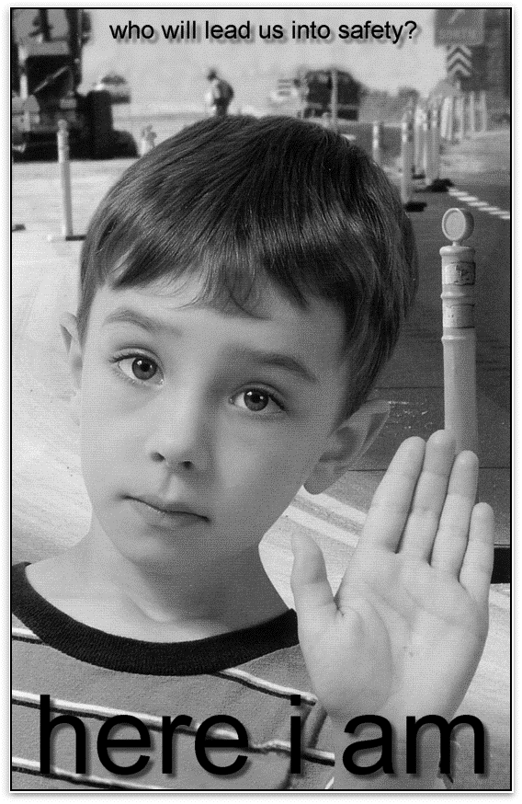
Steinbach United
Summer August 7, 2016
Let There
Be Light!
And now, dear brothers and sisters, one final thing. Fix your thoughts on what is true, and honorable, and right, and pure, and lovely, and admirable. Think about things that are excellent and worthy of praise. PHILIPPIANS 4:8
Keep On the Sunny Side

There's a dark and a troubled side of life
There's a bright and a sunny side too
Though we meet with the darkness and strife
The sunny side we also may view

Keep on the sunny side
Always on the sunny side
Keep on the sunny side of life
It will help us every day
It will brighten all our way
If we keep on the sunny side of life

Though the storm and its fury breaks today
Crushing hopes that we cherish so dear
Strom and clouds will in time pass away
The sun will shine again bright and clear

Let us greet with a song of hope each day
Though the moment be cloudy or fair
Let us trust in our Savior always
To keep us every one in God’s care

Sunday Morning Service August 7, 2016

Announcements and Sharing of Celebrations

We will follow along in our Hymnals as there is no Visual Projection for the summer months.

Songs: “Let Us Build A House” MV 1
“It’s a Song of Praise to the Maker” MV 30

Sharing and Learning “Half Full? Half Empty?”

Song “Keep On the Sunny Side”

Readings Psalm 33 (responsive); VU 760
Isaiah 1: 10-20
Luke 12: 32-40

Reflections “Investment Opportunity”

Song “Spirit Open My Heart” MV 79

Pastoral Prayer and Lord's Prayer

Mission Minute – “Sharing an Overseas Heart”

Offering Song “What Can I Do?” MV 191

Sending Song “Arise, Your Light is Come” VU 79

Blessing and Passing the Peace

Let Your LIGHT SHINE!

NEWS AND NOTES

Agape Sunday- We have changed back to the First Sunday of the month for the Agape House - Reverse Offering

“Busy Bags” - for the younger children available at the rear of the church.

Blood Donor Clinic – Saturday, August 13th 10:00AM – 1:00PM Charleswood United Church.

The cast and crew of Charleswood United Church Musicals are proud to present “ Honk”. Show times are Thursday, September 8th & Friday, September 9th at7:30 p.m. and Saturday, September 10th at 2:00 & 7:30 p.m. Doors open 30 minutes prior to show time.
Tickets are $12/adults in advance, $15/adults at the door and $8/children 12 & under. Tickets will be available after Sunday worship services and at the church office during the week beginning August 7th.
Please call the church office at 204-832-3667 for more information.

A thank you letter from Reverend Dr. Sharon Wilson was received. For anyone wishing to read her thank you message to this congregation, the Letter is posted up at the Bulletin Board outside the office door.

Steinbach United Church
541 Main Street, Steinbach, MB R5G 0L5
Phone: 204 326-3713 Fax: 204 346-9065
E-mail address: steinbachunited@mymts.net
Web site: www.steinbachunitedchurch.ca
Minister: Rev. George Feenstra Cell: (204) 381-2910
Emergency: (204) 381-6286; Email: george@geofeepub.com
Office Administrator: Pearl Wintoniw 204-371-8958
Treasurer: Dave Burr, e-mail: dave.burr@hotmail.com

