“We can easily forgive a child
who is afraid of the dark; the real tragedy of life is when grownups are afraid of the light.” Plato
Steinbach United
FEBRUARY 19 2017
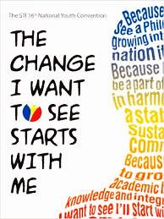
“Self-care is never a selfish act - it is simply good stewardship of the only gift I have, the gift I was put on earth to offer others. Anytime we can listen to true self and give the care it requires, we do it not only for ourselves, but for the many others whose lives we touch.”
Parker J. Palmer

Looking Ahead
It was wonderful to have guests from the Unitarian Universalist community with us last Sunday. I spoke with several of the persons and was very pleased to hear their comments about first impressions they had. Each person mentioned how inviting and comfortable our meeting space was. They went on to speak about the friendly attitude of our community. While they talked I felt the rise of a quiet pride in who it is that we are together as persons of faith.
Looking forward we are well aware that change is in the works. So much of what we have taken for granted along the way of our experience is now being called into question. Large settled answers are no longer adequate. This is nothing new. Again and again in the history of humanity people have had to adapt to changing circumstance.
We are in the days of decision. Each of us has opportunity to get involved in the free, responsible, creative and courageous work of making our shared world a place of health and happiness for all persons. Are you up for the challenge?
Sunday Morning Service February 19, 2017

Announcements and Sharing of Celebrations

Songs “Called By Earth and Sky” MV 135
“Love Is the Touch” MV 89

Sharing and Learning “Peer Pressure” (Dare to be you)

Reading “Psalm 139” (responsive with refrain) VU 861

Song “It’s A Song of Praise to the Maker” MV 30

Scripture Judges 6: 25-30; Matthew 5: 38-45

Reflections “You Have Heard it Said, But I Say to You”

Song “We Are Pilgrims” VU 595

Pastoral Prayer

Mission Minute “Rendez-vous!

Offering Song “What Can I Do?” MV 191

Song “I’ve Got Peace Like a River” VU 577

Blessing and Passing the Peace

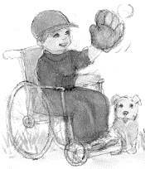
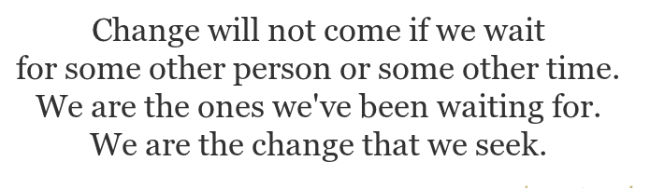
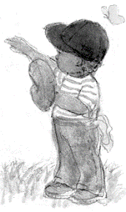

NEWS AND NOTES
Happenings This Week:
NO Prayer Breakfast this Monday. Resumes Feb 27th.
Looking Ahead
Feb 26 – Worship Service and Annual Meeting will take place in the CE Hall.
Feb 27 – Prayer Breakfast 9-10AM
Feb 27 – Book Study 7:15
Feb 28 – Shrove Tuesday Pancake Supper –starting at 5:30PM.
Free will offering. Net proceeds will go to the M&S Fund.
March 1st – Ash Wednesday

Annual Report 2016 – Pick up your copy today.
Please bring your copy along with you when attending the Annual Meeting on Feb. 26th. Thank you.

Book Launch of “Malignant Memory” by Barbara Paterson Sunday Mar 05 at 2:00 pm, Winnipeg, Grant Park in the Atrium. The book is also available through Amazon or Chapters online. See the poster for information about the book
Providence College Lecture Series – Steinbach Arts Council @7PM “The Family and the Church: A Journey through Social History”.

Hope Centre Ministries is holding their IN2017 Conference, March 3-4, at Westwood Community Church. The conference holds workshops to help attendees learn about and celebrate the gifts of people with disabilities in our faith communities. For more info see poster.
Steinbach United Church
541 Main Street, Steinbach, MB R5G 0L5
Phone: 204 326-3713 Fax: 204 346-9065
E-mail address: steinbachunited@mymts.net
Web site: www.steinbachunitedchurch.ca
Minister: Rev. George Feenstra Cell: 204 381-2910
Emergency: 204 381-6286; Email: george@geofeepub.com
Office Administrator: Pearl Wintoniw 204-371-8958
Treasurer: Dave Burr, e-mail: dave.burr@hotmail.com

