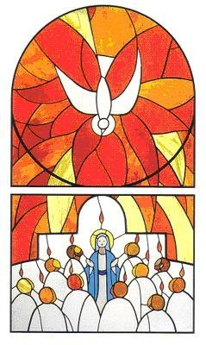
HERE AND NOW
PENTECOST
Steinbach United Church
June 11 2017
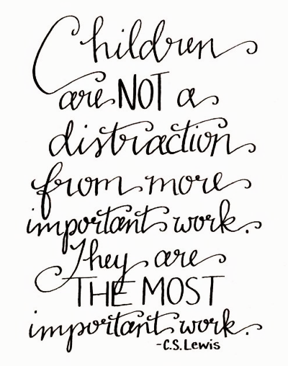
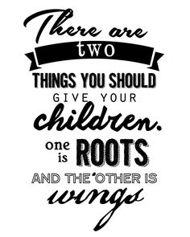
A SHARED LIFE OF FAITH IN ACTION
Today we are noticing the place that children play in our shared hopes. They offer us the opportunity to think about what really matters in life. Choosing to dedicate our personal resources of energy and time as a way of supporting and encouraging young persons to grow in confident hope offers rewards that cannot be measured. The sheer delight of seeing a young boy or girl grow into the fullness of their gifts and abilities is true treasure.
We have two fine examples of this dedicated investment in the hope of cultivating grace and faith in our church community’s children. Bev and Andrea, working together with a team of helpers and assistants, have consistently provided opportunities for fun and friendship as well as learning about the way of God and the way of this present world.
Things are going to be changing during the next months. This change provides an opportunity for each of us to think again about what we are prepared to invest in the future of our faith community and tradition. Hopefully each of us will dedicate some serious thought to exploring ways of getting involved with supporting and encouraging each and all who step forward to offer time, talent and treasure to ensure that the future will be bright for our children and their children after them.
We are called to love God and to love our neighbours. Hopefully each of us will answer this call faithfully.

Sunday Morning Service June 11, 2017

Announcements and Sharing of Celebrations

Songs “I Am a Child of God” MV 157
“Like a Rock” MV 92

Sharing and Learning “Children and Youth Commencement”

Song “Come O Holy Spirit” MV 23

Scripture Acts 2: 1-4; 1 Corinthians 12: 4-12

Reflections Many Gifts – One Spirit

Song “Deep In Our Hearts” MV 154

Mission Minute “The Healing Fund is Changing Lives”

Offering Song “I’m Gonna Live So…” VU 575

Pastoral Prayer

Song Praise My Soul, the God of Heaven VU 240

Blessing and Passing the Peace

“Spirit, Spirit of gentleness blow thro’ the wilderness calling and free, Spirit, Spirit of restlessness, stir me from placidness, Wind, Wind on the sea.”
~James K. Manley

NEWS AND NOTES

Happenings of the Week:
- June 14th- 2:30PM- Sing Song at Bethesda Place
- June 18th- Worship in the City (SCU Main Stage)
Note: There will be no service next Sunday, June 18th, as Worship in the City will be taking place at the SCU Main Stage at 10:30am
Looking Ahead
June 21st- 11AM-3PM-Quirky Quilters Meeting
June 25th- Farewell service & picnic for George and Barbara
August 16th to 19th-Rendez-Vous National United Church Youth Retreat in Montreal

Worship in the City – June 18th at 10:30 at the SCU Main Stage - Guest Speaker – Milt Stegall; Music by Danny Plett & Project Worship. Christian Artists preforming all day Sunday. See poster for details.
Summer in the City: Volunteers needed! Contact Alyx at 204-392-3378
Farwell Service & Potluck – George’s last Service (June 25th) – BBQ lunch (Hamburgers and Hot dogs and potato Salad provided) with salads and desserts as potluck.
146 Pathways to Treaty Relations- Join Jennifer Preston and Allen Sutherland in an afternoon of Treaty talks and workshops on June 25th at 2pm. Please see poster in front entrance for details.
Eden’s East-side Road Ride cycling event- Bike 80 kms from La Broquerie to Woodridge and back in support of mental health recovery on Saturday, Aug 19th. See front entrance for more info.
Living Proof Live Simulcast with Beth Moore- Steinbach Bible College is offering an event on Sept 16 to women in Southern Manitoba and Northern Ontario. Please see poster in front entrance for details.
Steinbach United Church
541 Main Street, Steinbach, MB R5G 0L5
Phone: 204 326-3713 Fax: 204 346-9065
E-mail address: steinbachunited@mymts.net
Web site: www.steinbachunitedchurch.ca
Minister: Rev. George Feenstra Cell: 204 381-2910
Emergency: 204 381-6286; Email: george@geofeepub.com
Office Administrator: Ally Klassen 204-320-1707
Treasurer: Dave Burr, e-mail: dave.burr@hotmail.com

