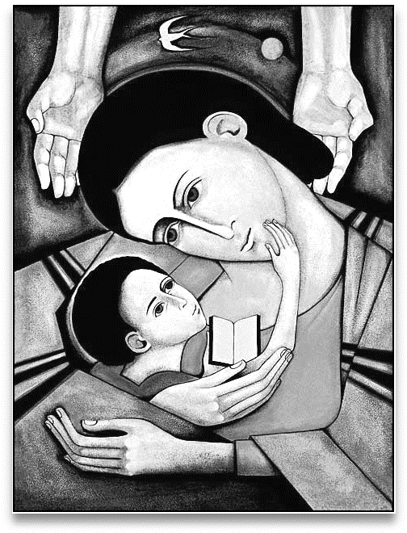
Steinbach United
Unto Us
A Story is Given
November 20 2016
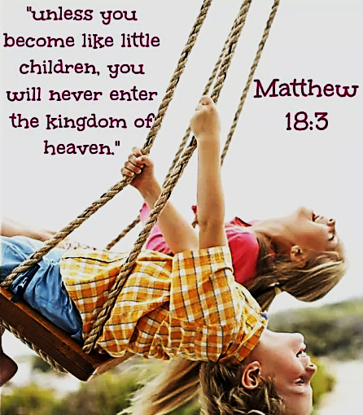
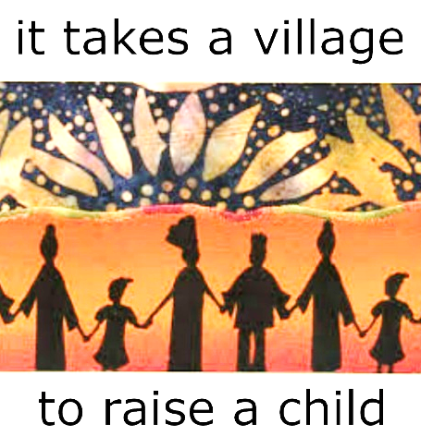
Communication = Community
On Monday evening the Church hosted two important conversations. In the CE building a team of persons gathered to explore our options as a community of faith. At the same time a circle of friends gathered in the sanctuary to share insights and encouragements rooted in the stories of the Bible.
There is a sense in which these two conversations represent our best hope going forwards. On one hand we are looking at the practical use of our available resources to strengthen our community so that it may go into the future with confidence and enthusiasm. On the other hand we are looking at the spiritual gifts which will serve to inspire and lead us forward with peace and purpose.
The future presents us with a wonderful opportunity to discover and implement goals and objectives which will bring benefit into our faith family, our neighbourhoods and our world. Your prayers and participation are a key part of this shared human hope.
Sunday Morning Service November 20, 2016

Announcements and Sharing of Celebrations

Songs “This is the Day” MV 122
“Come Children Join to Sing” VU 345

Sharing and Learning “Follow the Leader”

Song “Jesus Loves Me” VU 365

Reading “A New Creed” [unison]

Scripture Luke 2: 25-38; Luke 18: 15-17

Reflections “Unto Us”

Song “Spirit Open My Heart” MV 79

Prayer for the Future of Our Children

Mission Minute “Confirmation Retreat”

Offering Song “What Can I Do? MV 191

Song “I’ve Got Peace like a River” VU 577

Blessing and Passing the Peace
I love to tell the story of Jesus and his love…

NEWS AND NOTES

Monday 9-10AM - Prayer Breakfast – Everyone Welcome!
Mondays at 7PM – Sharing & Learning on Themes of the Bible with George in the Sanctuary. Every Monday in November.
Sunday After the Service Coffee Time – Anyone wishing to help with refreshments or serving our After Worship Coffee Time. Please contact Marlene (204-326-3908). Help is appreciated!
Looking Ahead
Messy Church – Dec 2nd 5-7PM Presents “Messy Christmas”. For all ages – fun, crafts, celebration time & Meal – NO Cost. More info found on bulletin board.
Women's Christmas Breakfast - Saturday, December 10th at 9:30 AM / CE Building. Promising great food and much fun! Women of all ages are welcome.
Children’s Christmas Service - Sunday, December 11th at 10:30
Christmas Carolling – Dec 11th at 6:00PM – meet in hallway between CE Hall and Sanctuary.

Oakbank United Church's Dinner Theatre is proud to present “The Masked Musketeer" from January 19 – February 11, 2017. Tickets for all performances are now available by phone at 204-960-9482. All tickets are $50 each, and include a $25 tax receipt. Please see www.oakbankdinnertheatre.com for full details.
Steinbach United Church
541 Main Street, Steinbach, MB R5G 0L5
Phone: 204 326-3713 Fax: 204 346-9065
E-mail address: steinbachunited@mymts.net
Web site: www.steinbachunitedchurch.ca
Minister: Rev. George Feenstra Cell: (204) 381-2910
Emergency: (204) 381-6286; Email: george@geofeepub.com
Office Administrator: Pearl Wintoniw 204-371-8958
Treasurer: Dave Burr, e-mail: dave.burr@hotmail.com

